JENKINS PIPELINE FOR JAVA MAVEN PROJECT:

By A. Angelena

22BD1A0585

1. This is the Jenkins Dashboard after you sign in

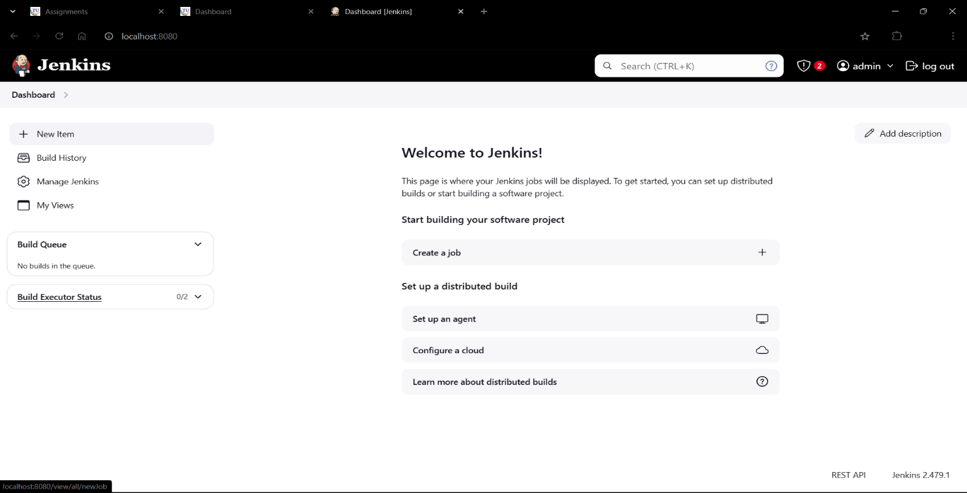

1. Click on New Item on the left of the dashboard

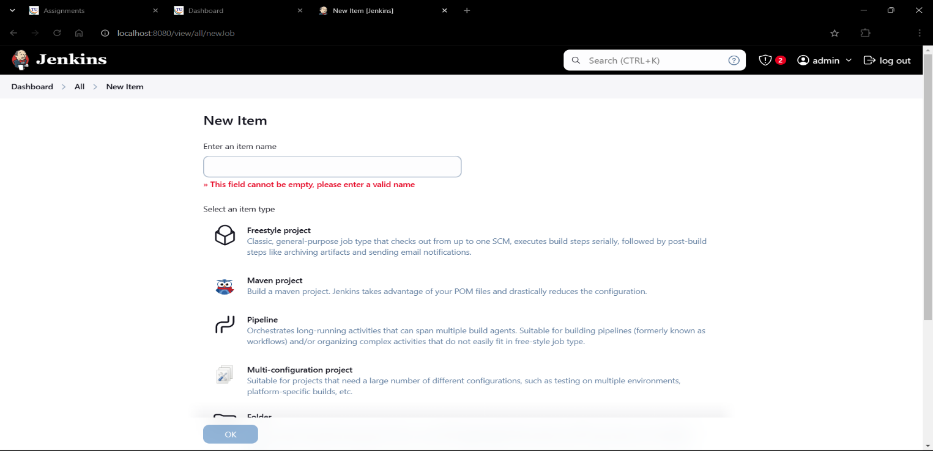

1. Give the item name as javasample_build

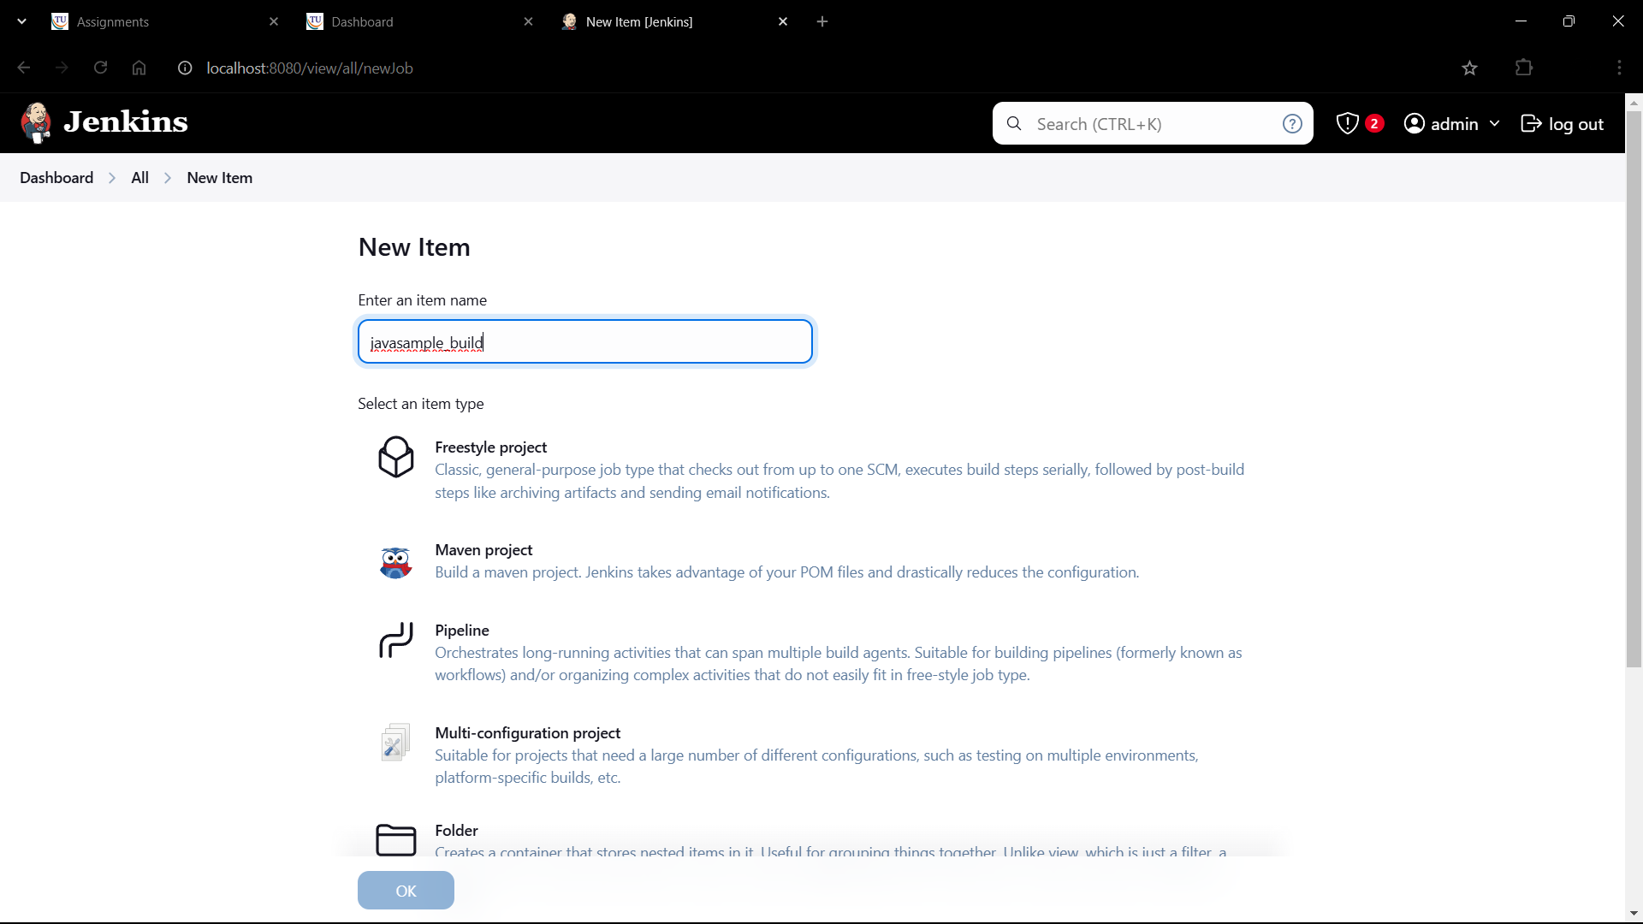

1. Select the item type as Freestyle project

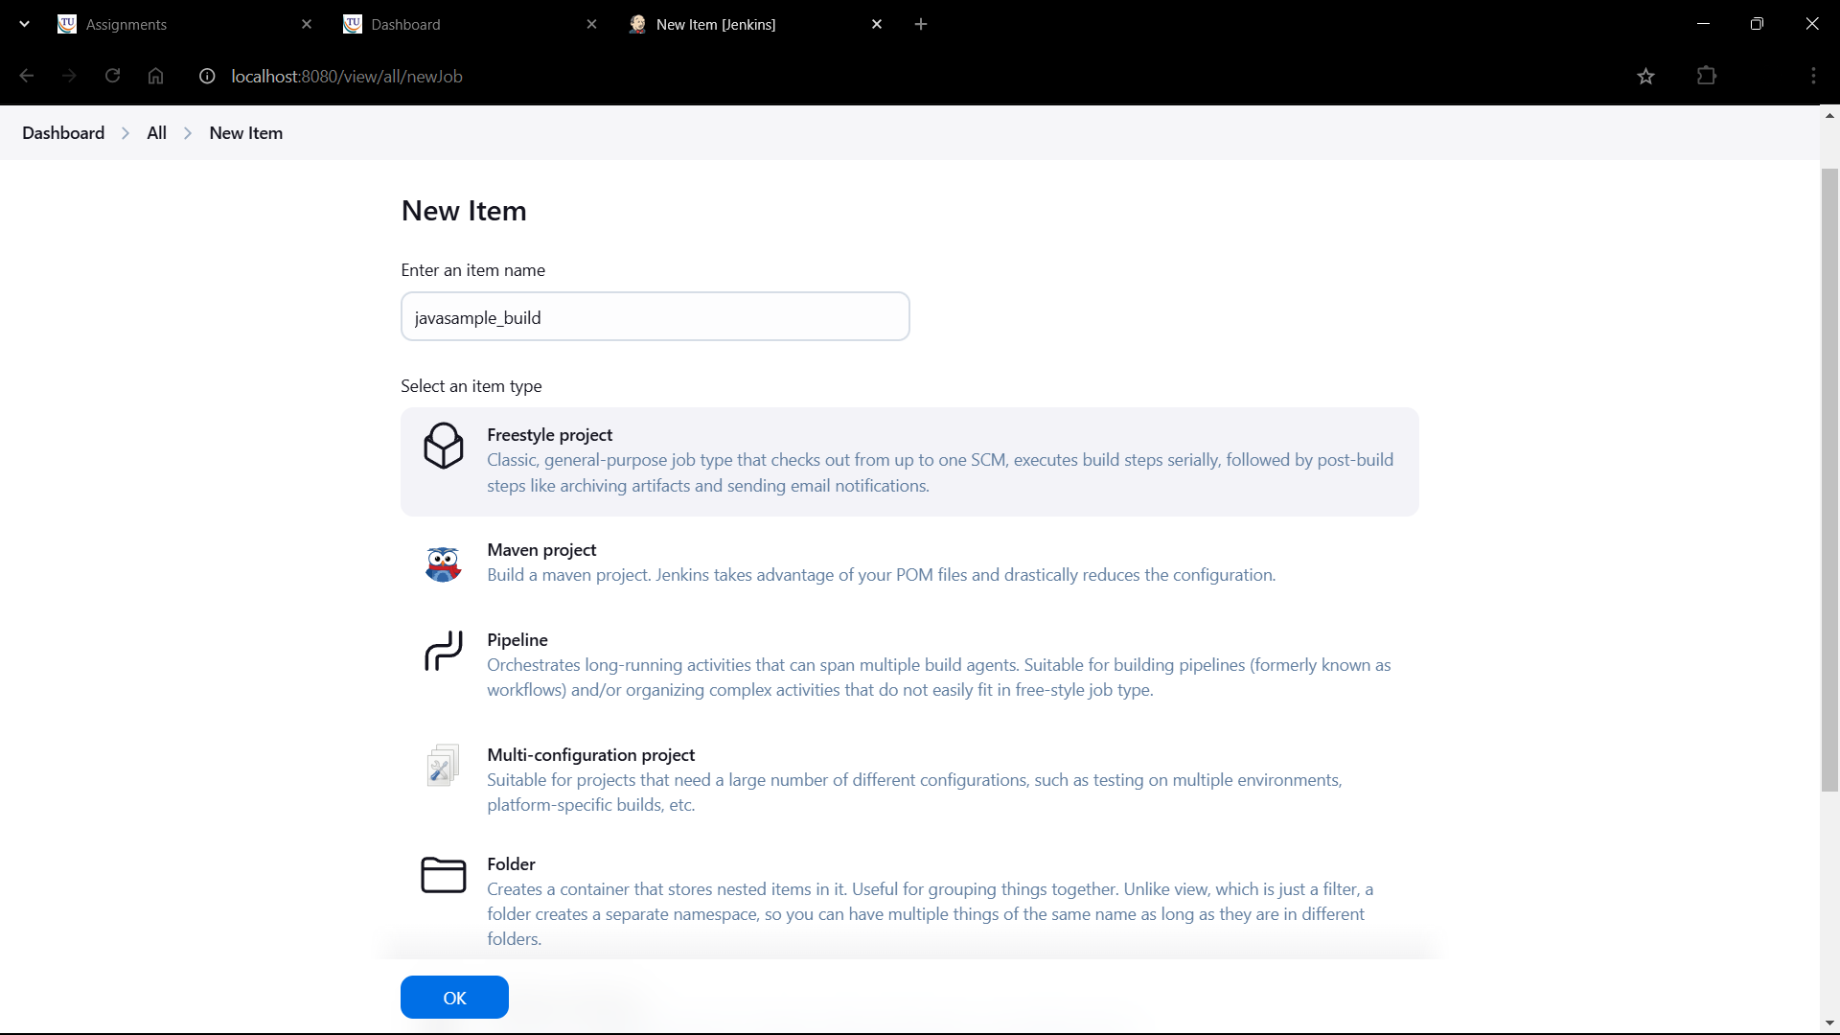

1. Click on Ok

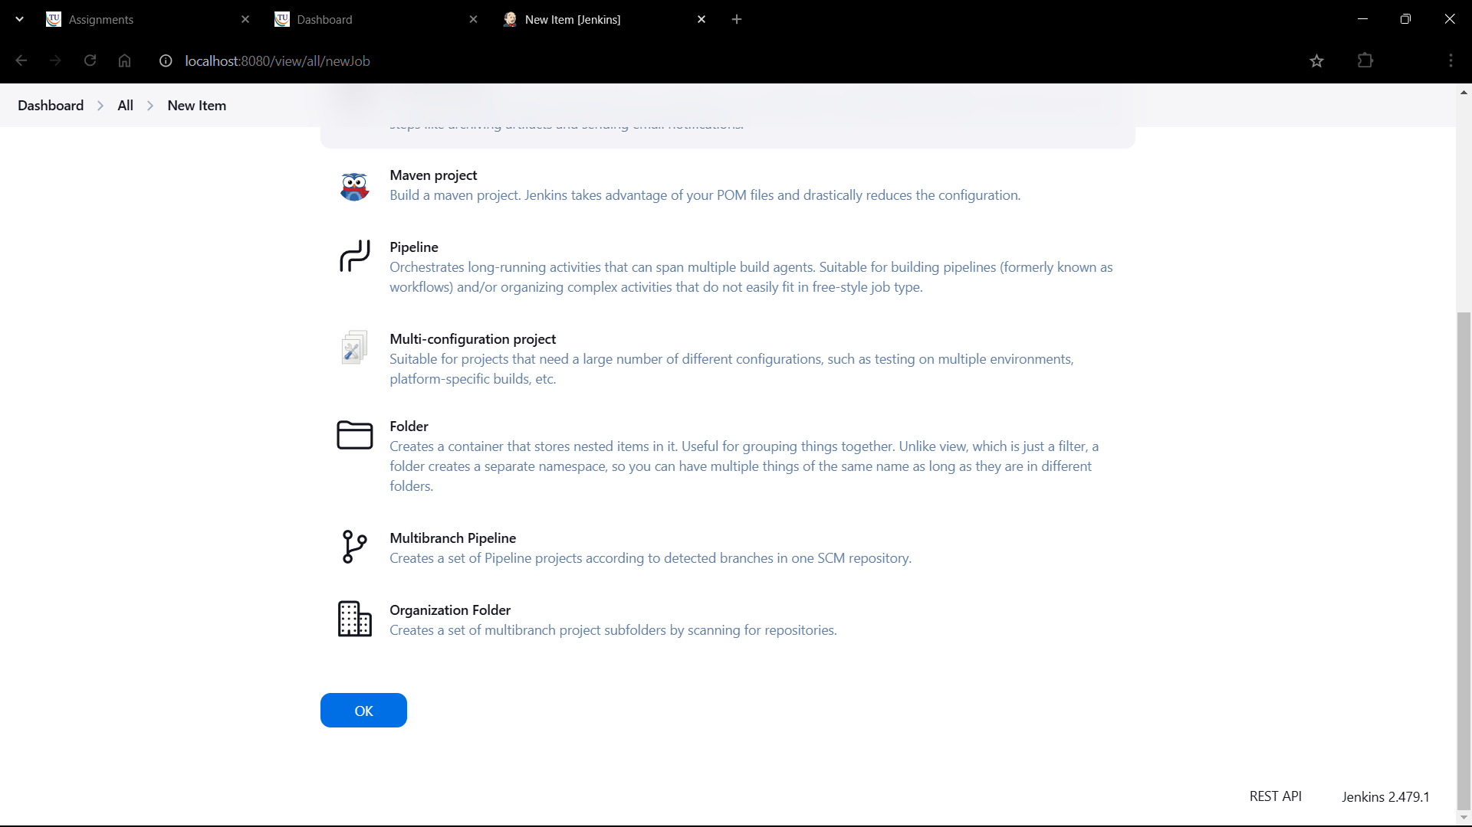

1. Scroll down and Select SCM as Git

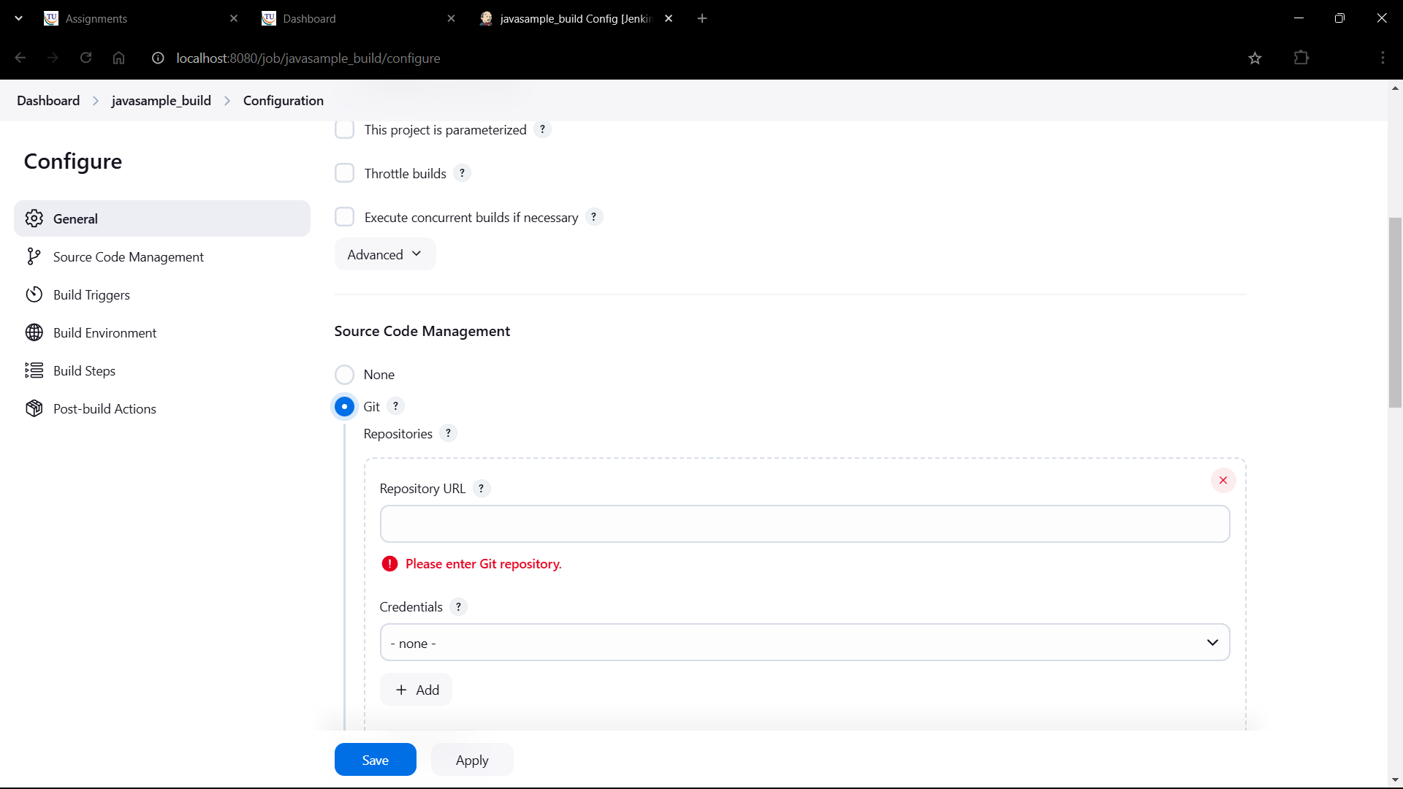

1. Go the your webapp repository on github

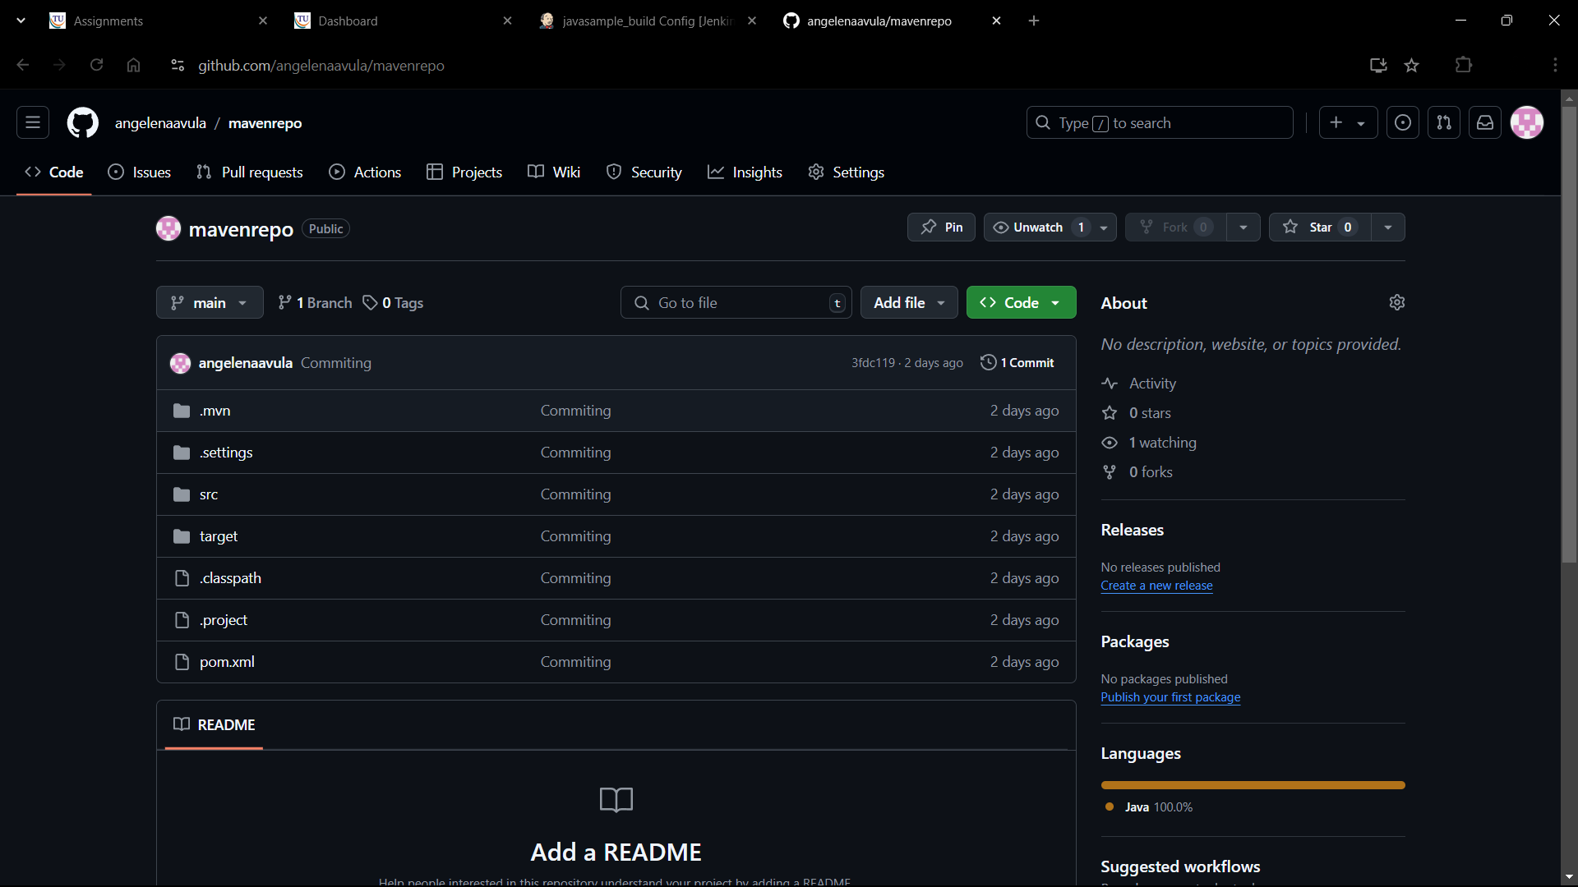

1. Copy the respository link

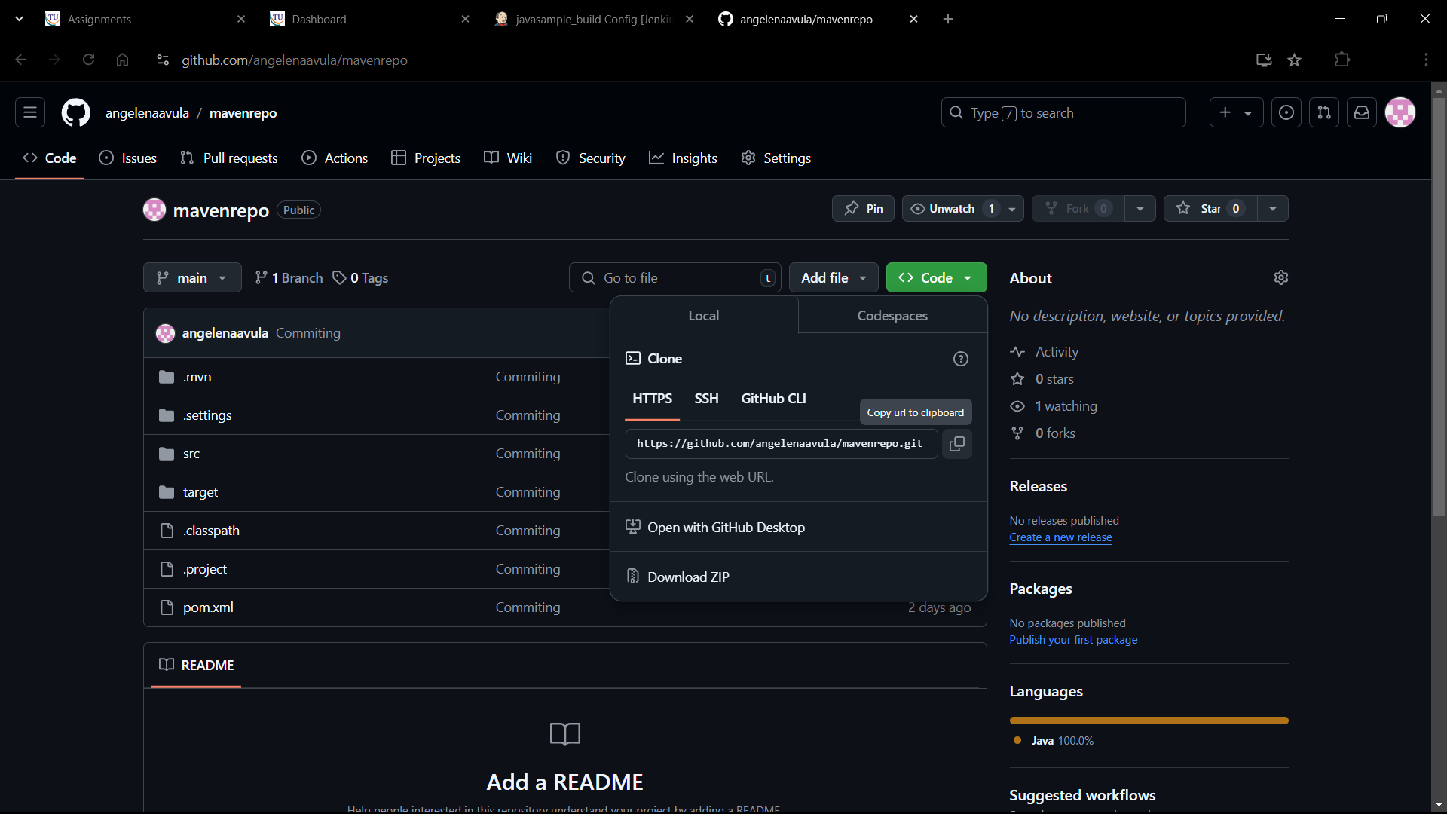

1. Paste the url at Repository URL

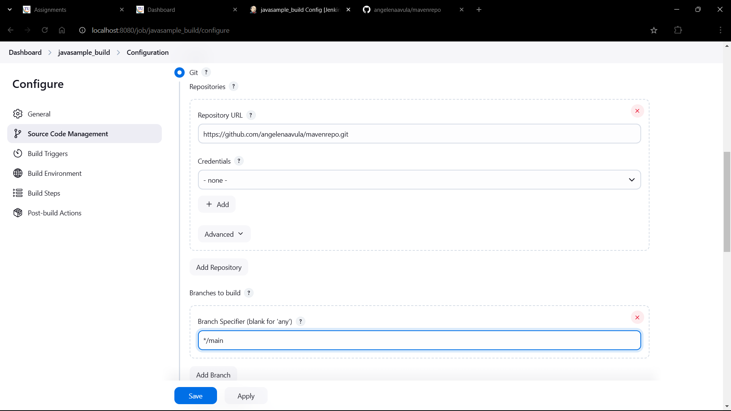

1. Mention your branch

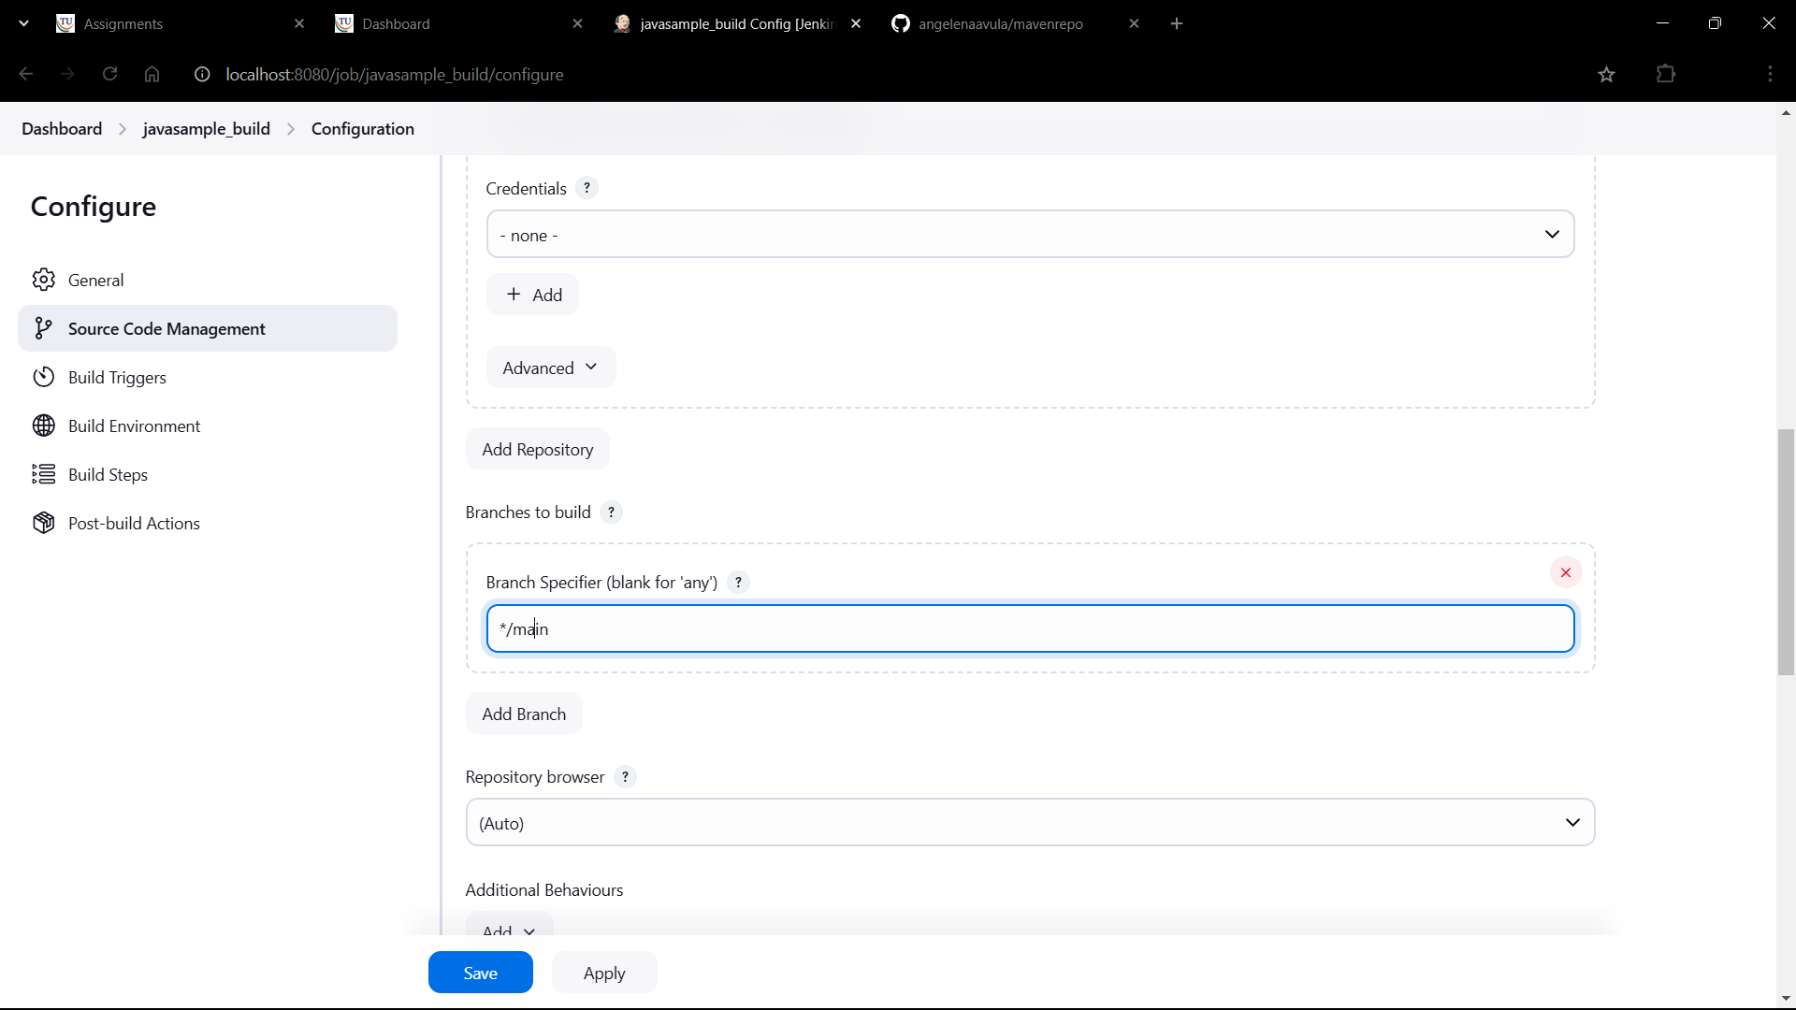

1. In build environment click on

Add build step->Invoke Top-level Maven targets

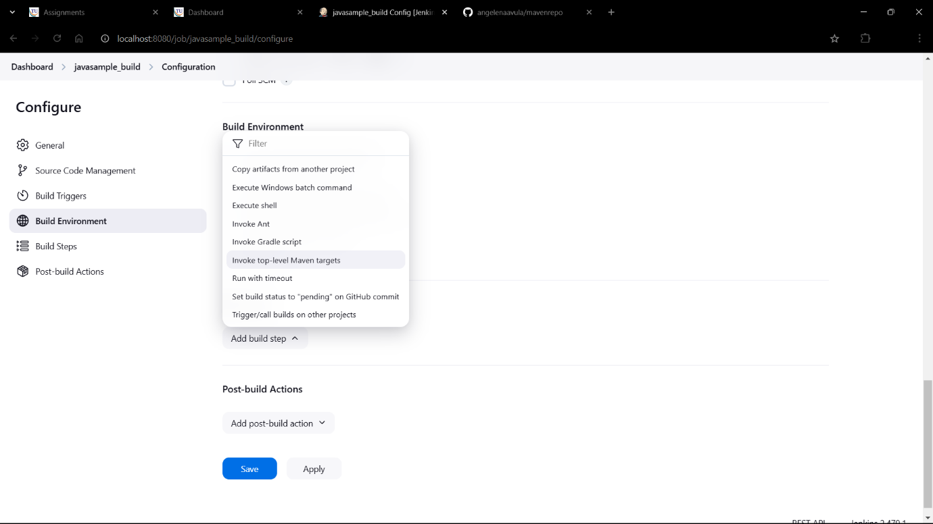

1. Give Maven version as MAVEN_HOME as we have configured earlier and give goals as Clean

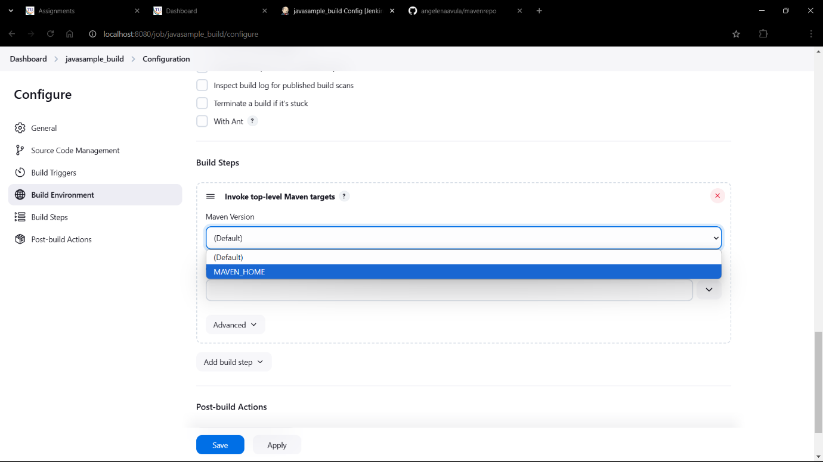

1. Add another invoke-top level Maven targets and give MAVEN_HOME and goals as install

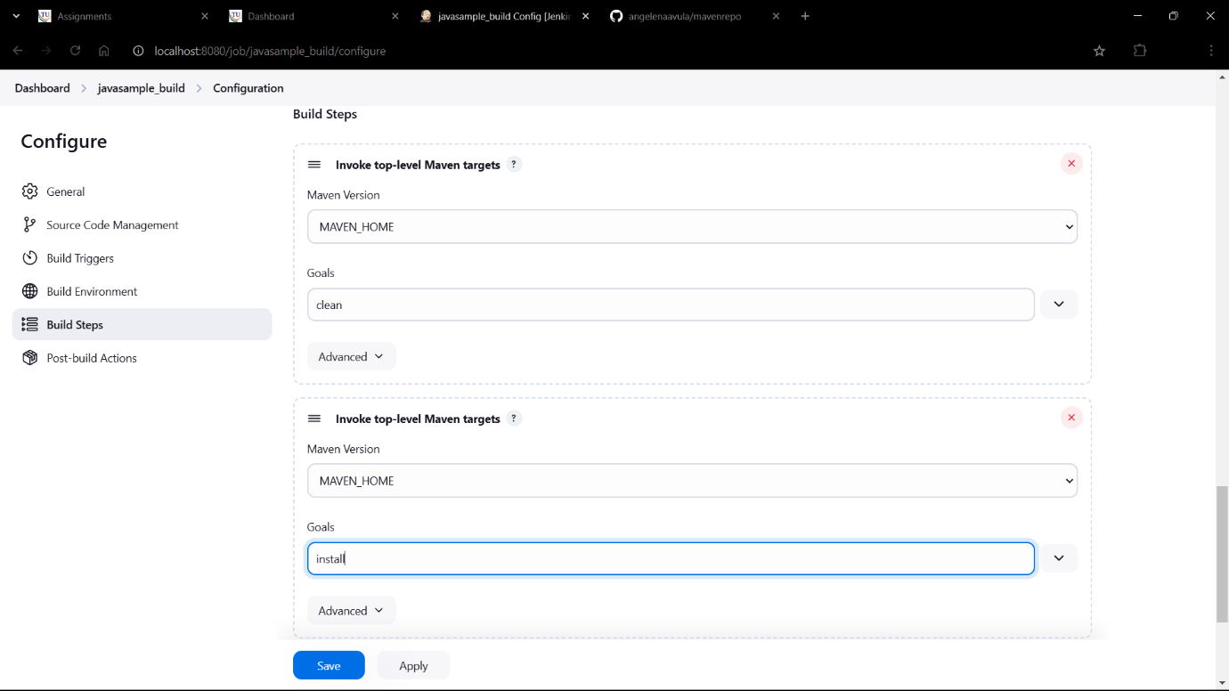

1. Click on

Add post-build action

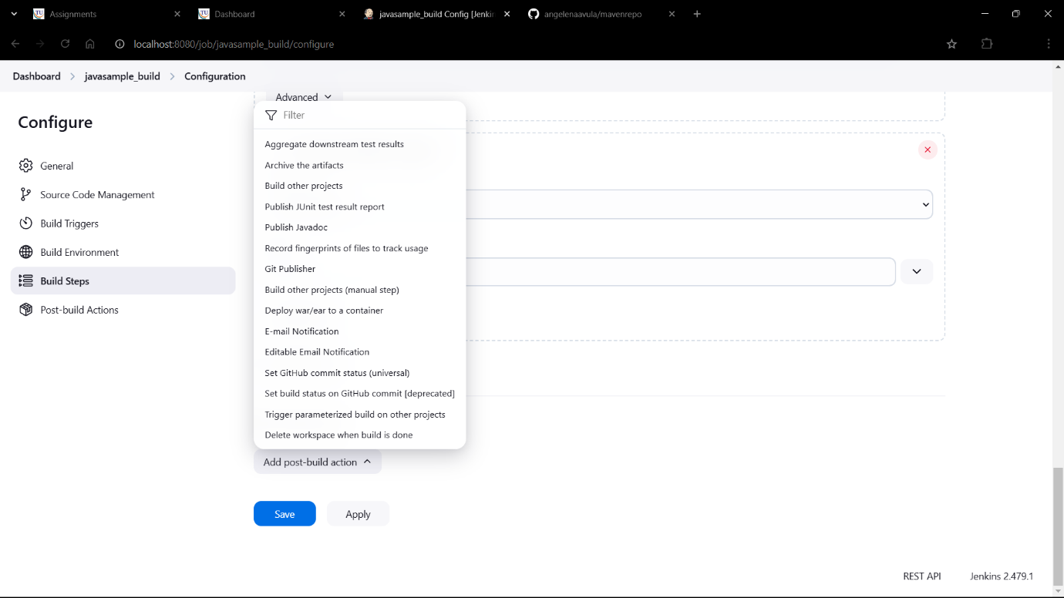

1. Select Archive the artifacts

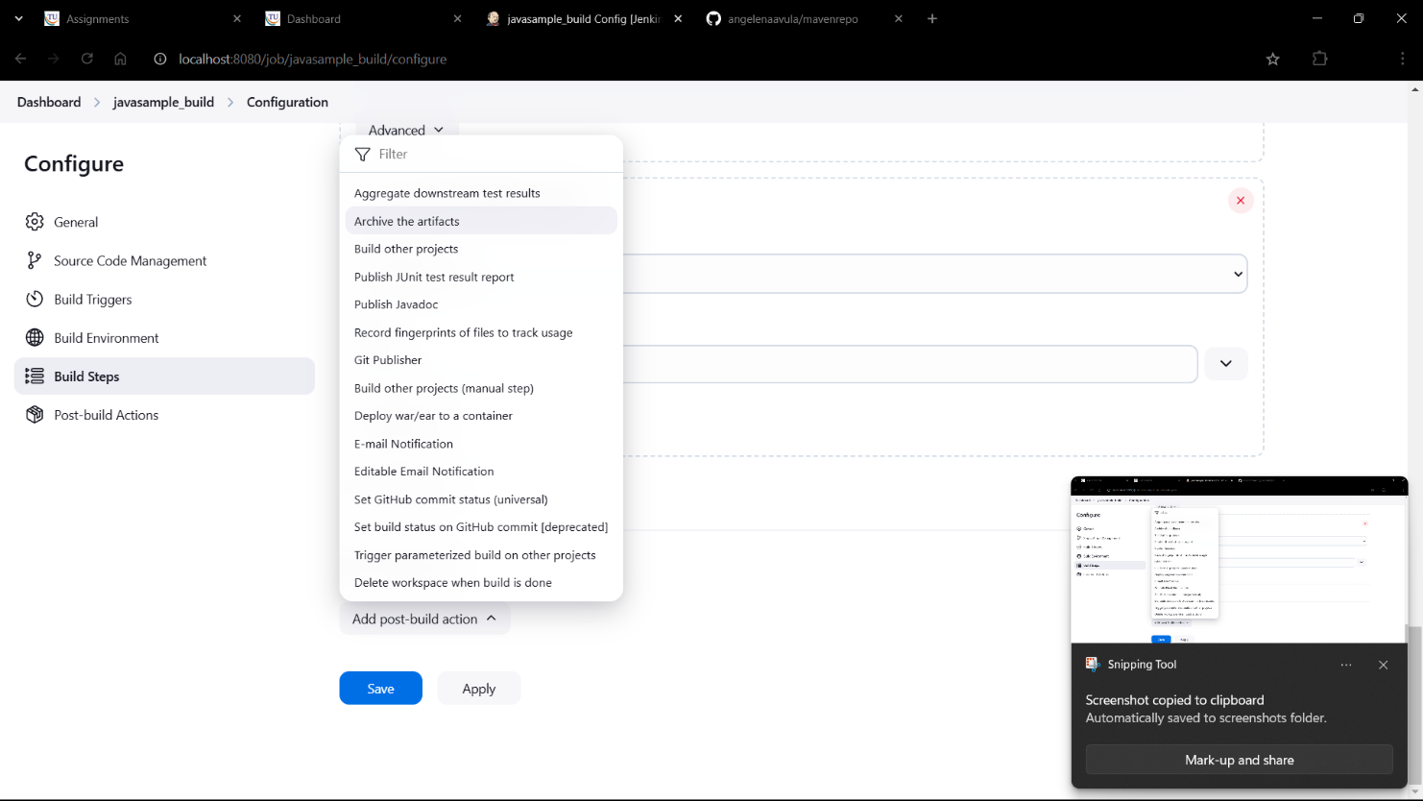

1. Give **/* in files to archive

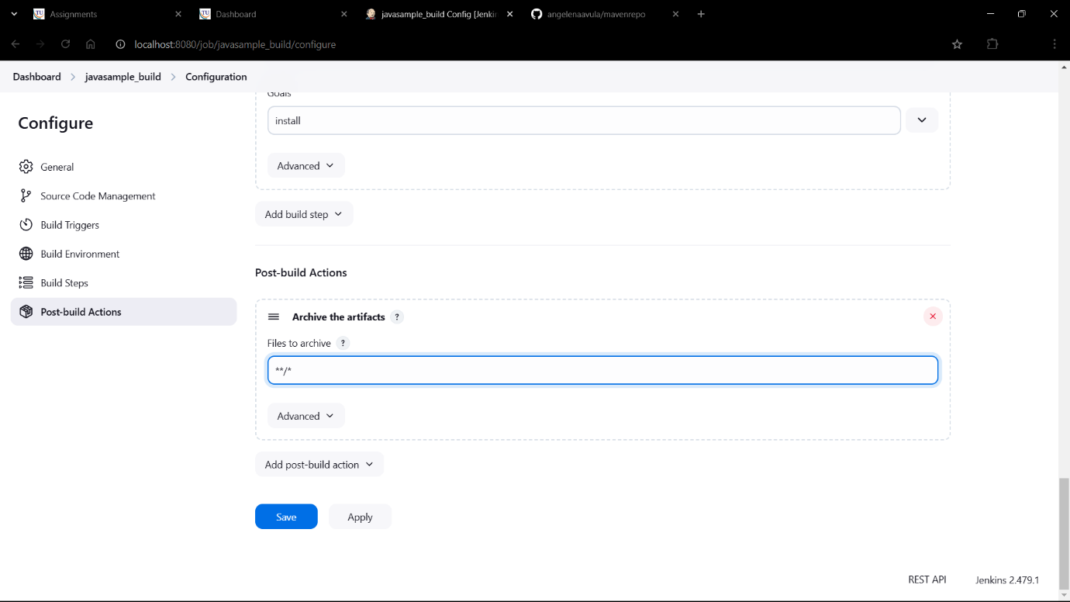

1. Add another post-build action:

Build other projects

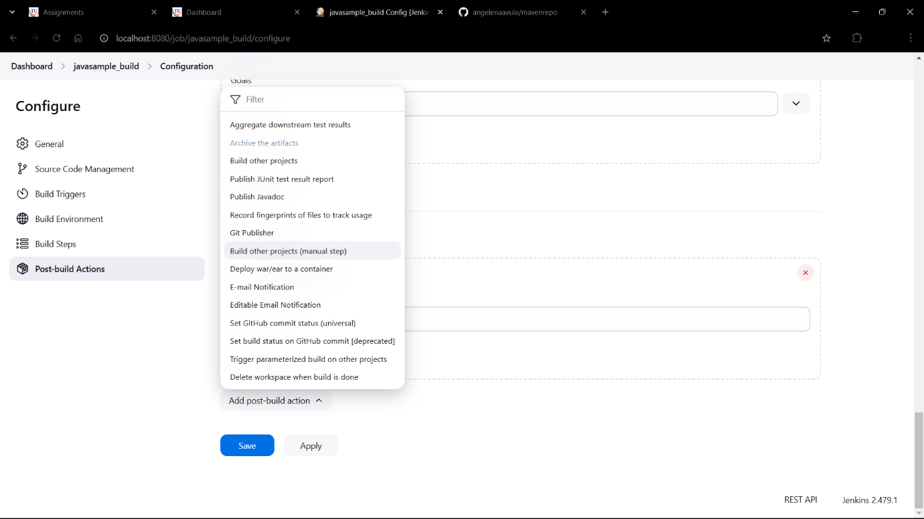

1. Give javasample_test as projects to build

Click on Apply->Save

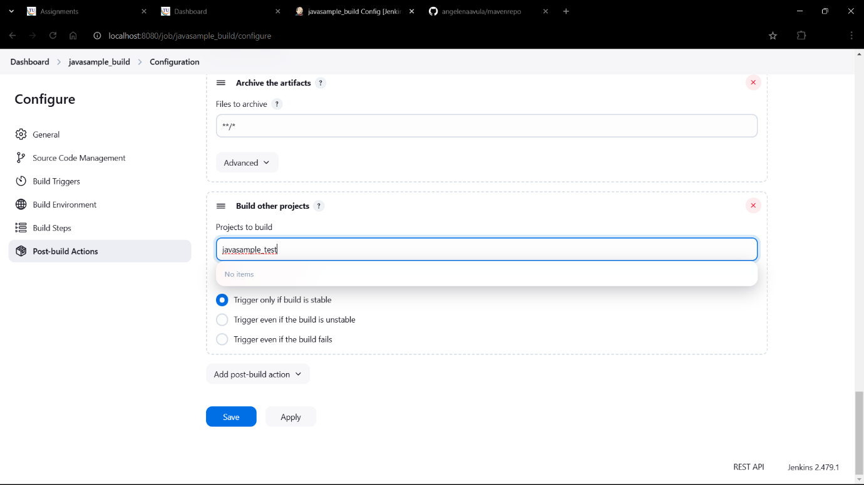

1. We can see the javasample_build, now click on New item again

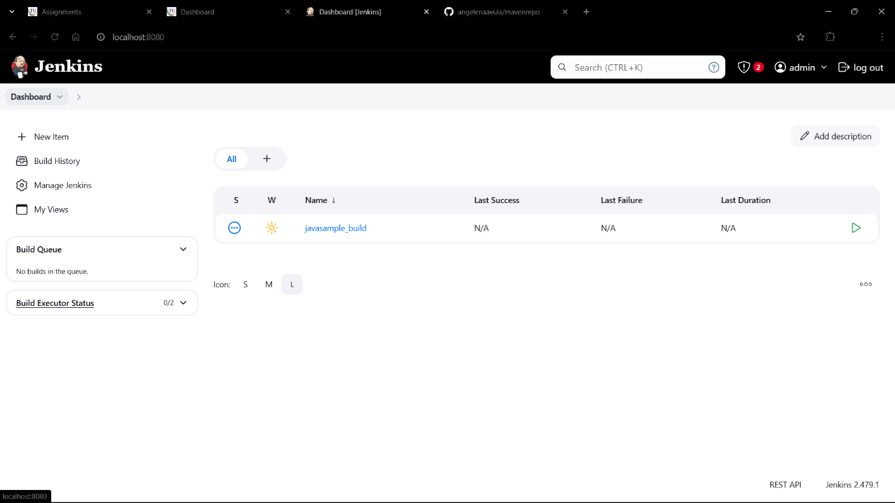

1. Give javasample_test as item name

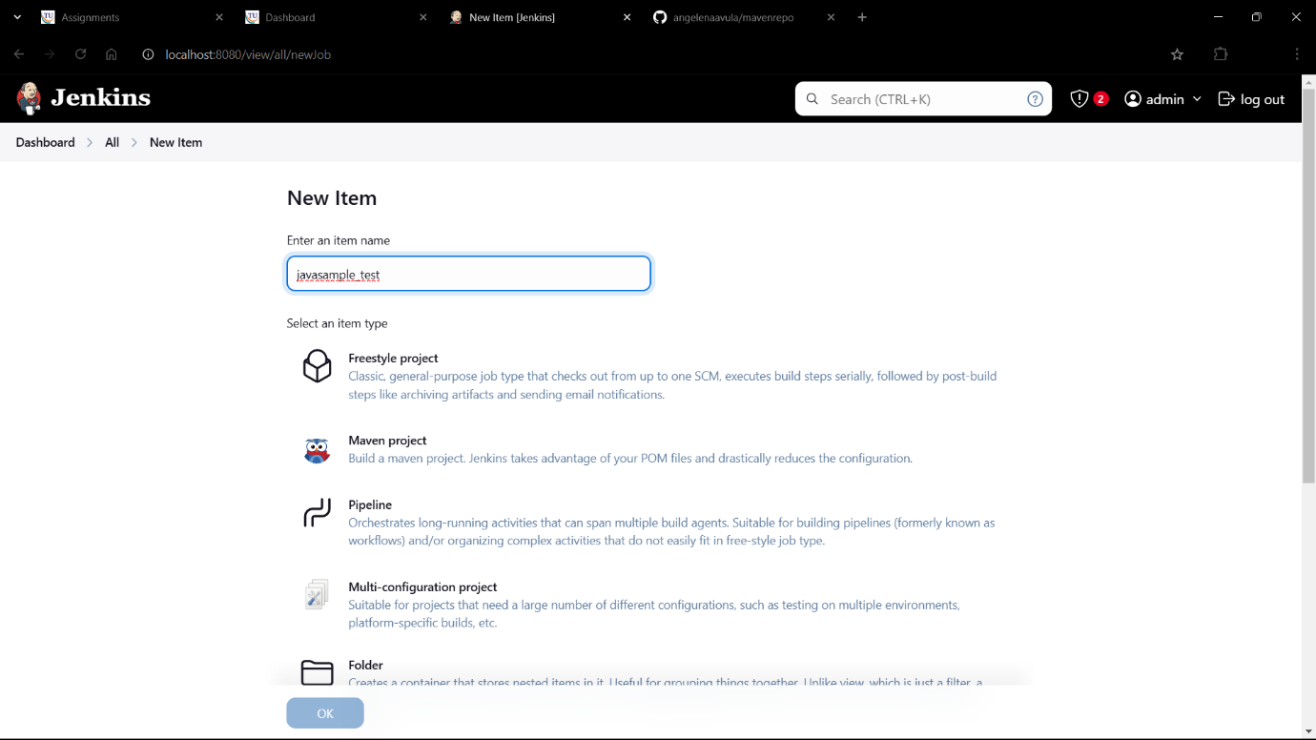

1. Select Freestyle Project and click Ok

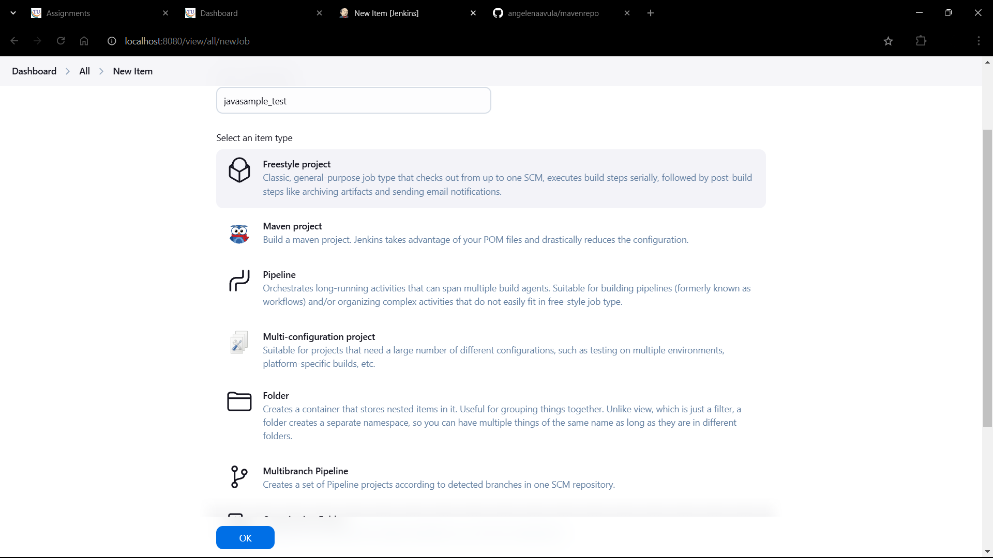

1. In build environment select Delete workspace before build starts

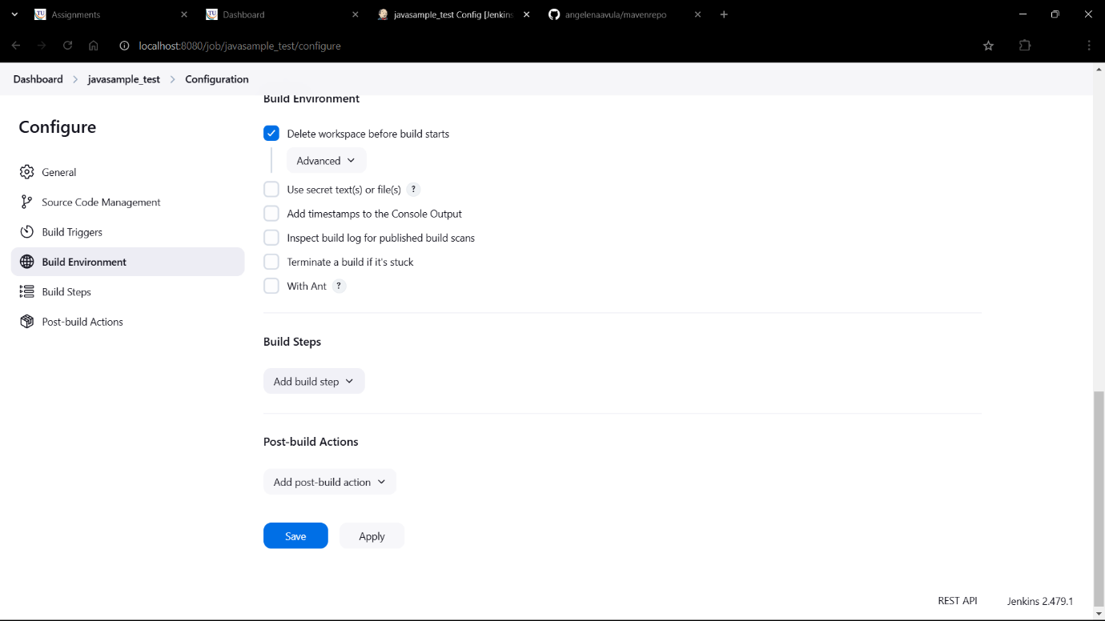

1. Click Add build step->Copy artifacts from another project

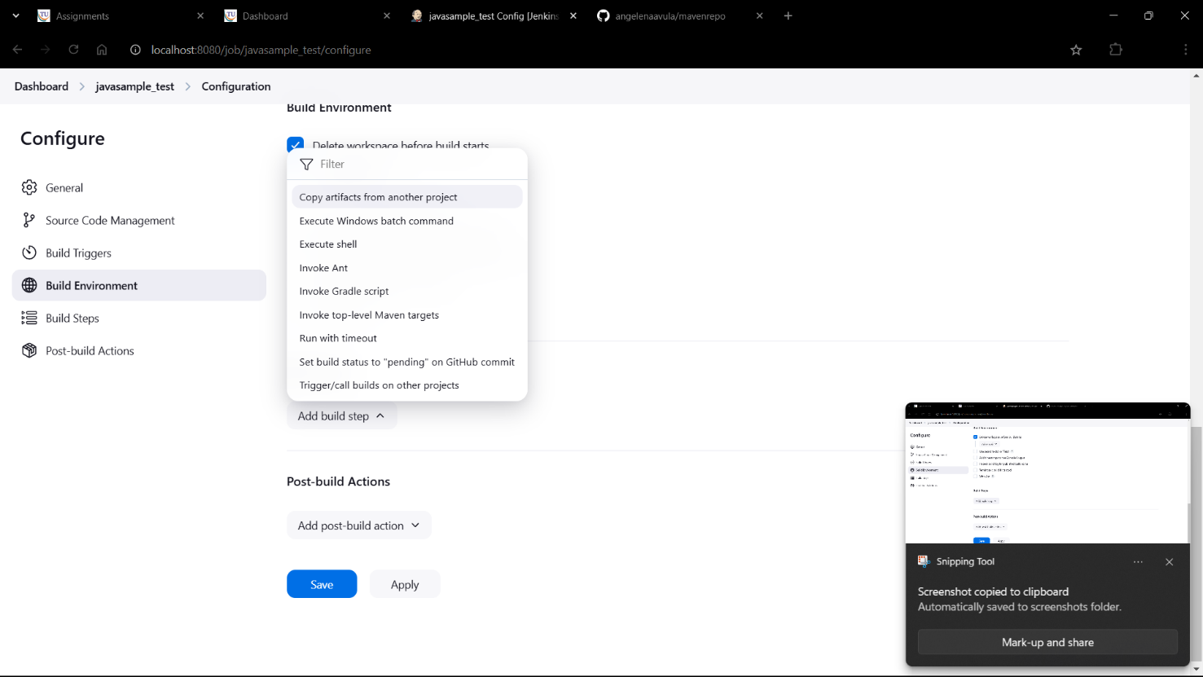

1. Give project name as javasample_build

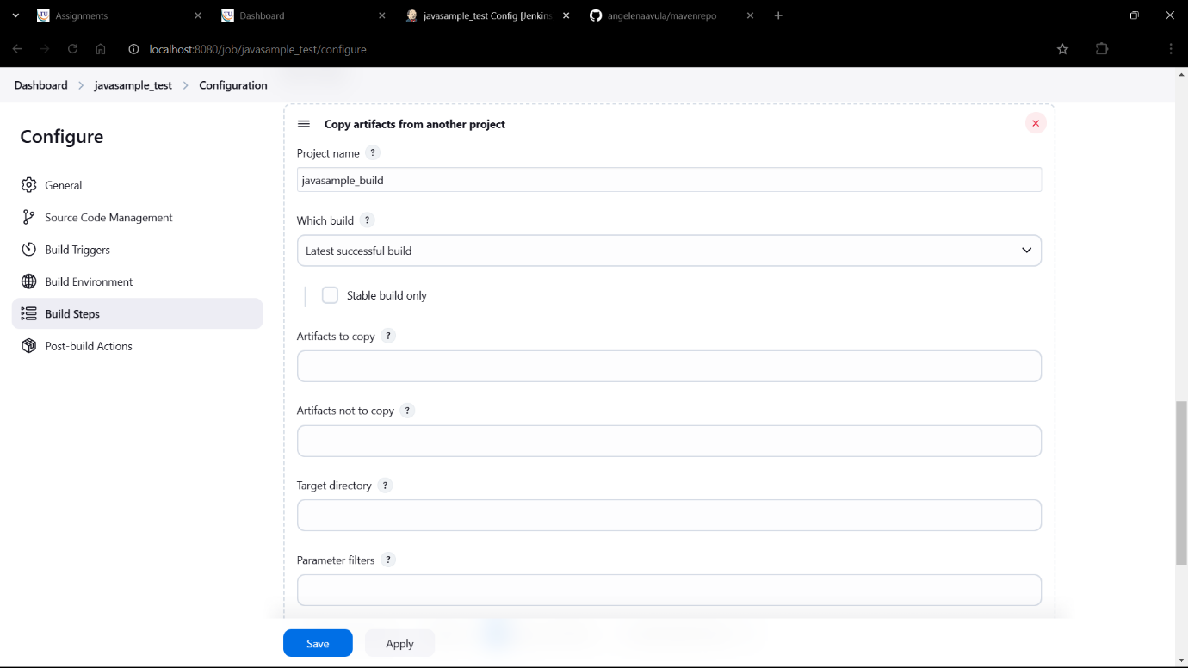

1. Select stable build only

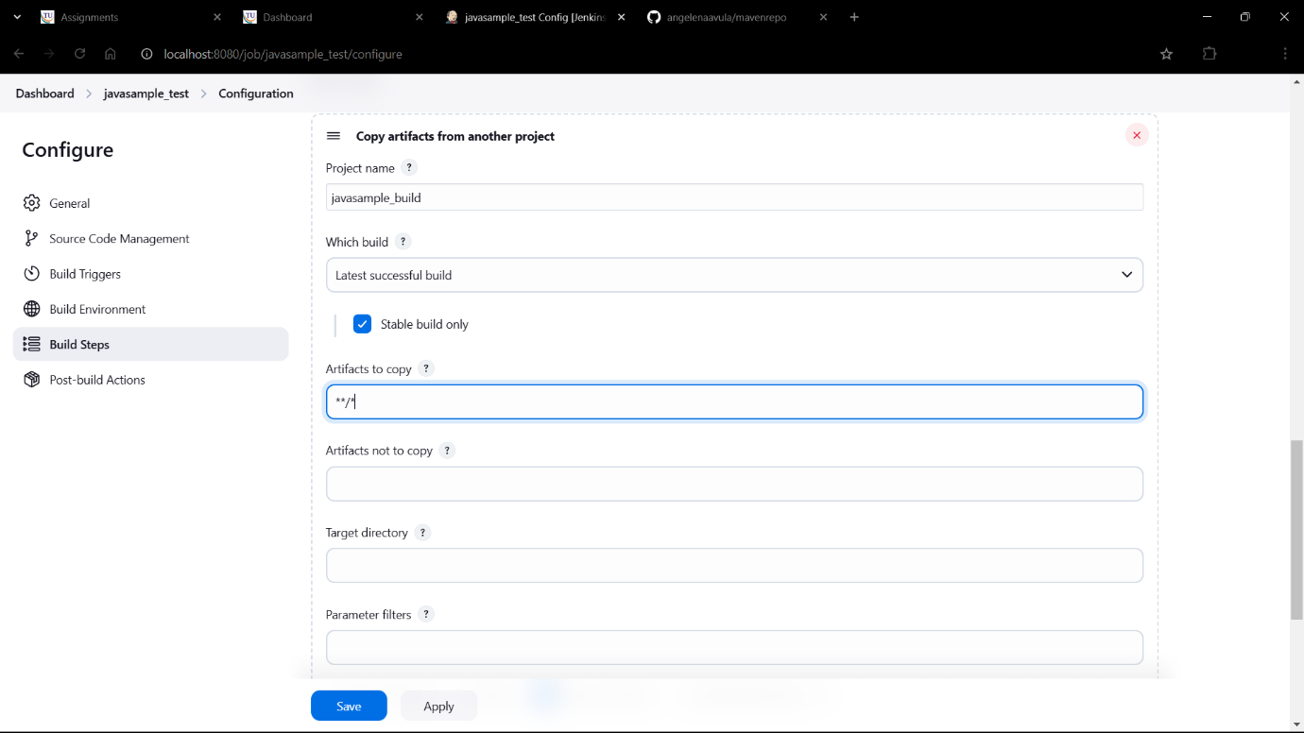

1. Click Add build step->Invoke top-level maven targets

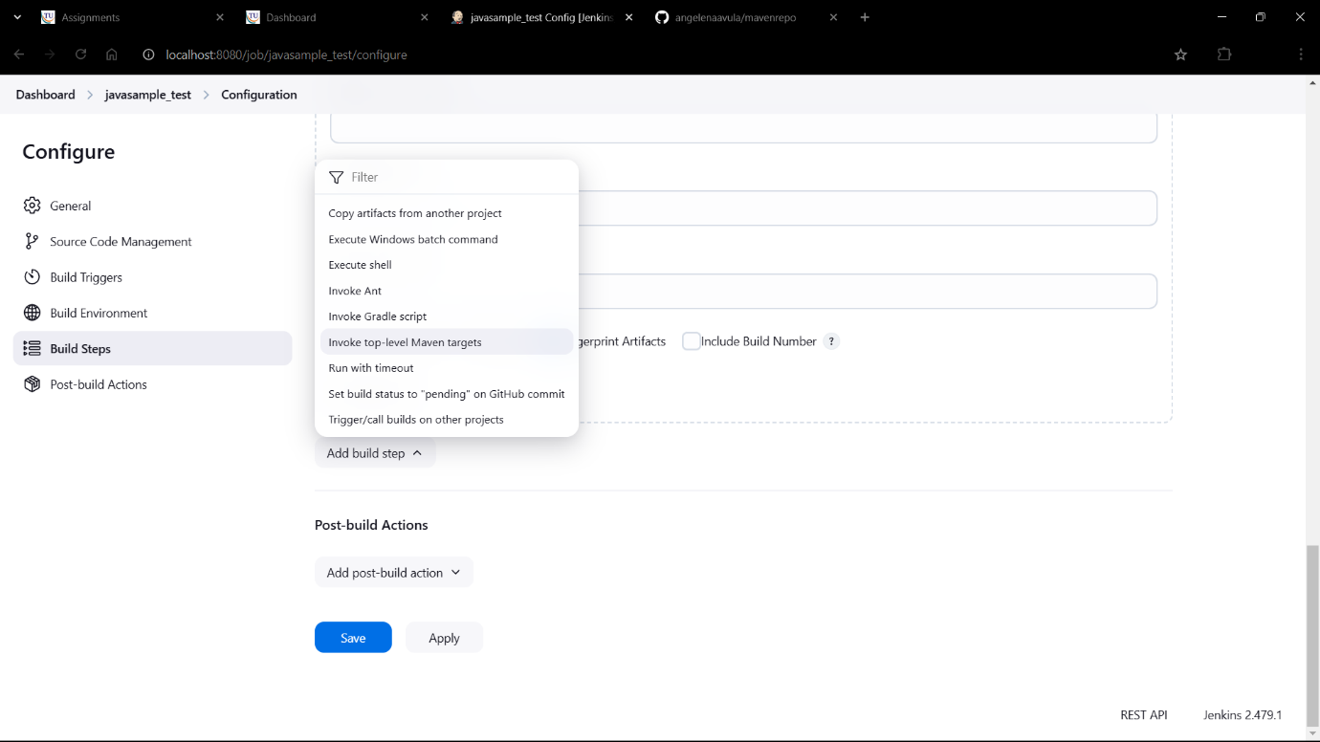

1. Give MAVEN_HOME path

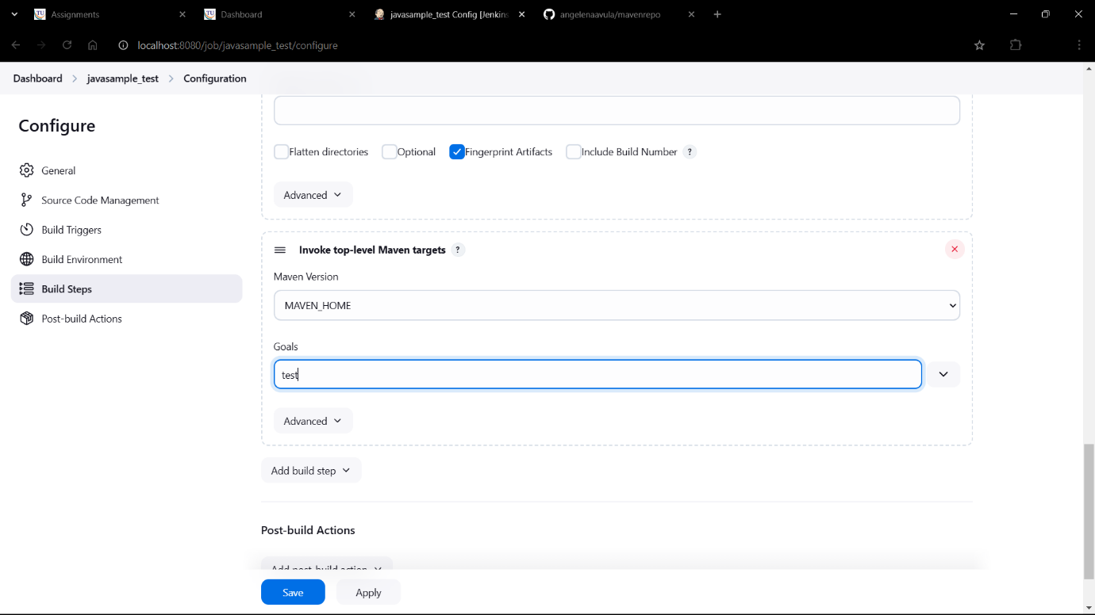

1. Click on Add post-build action->Archive the artifacts

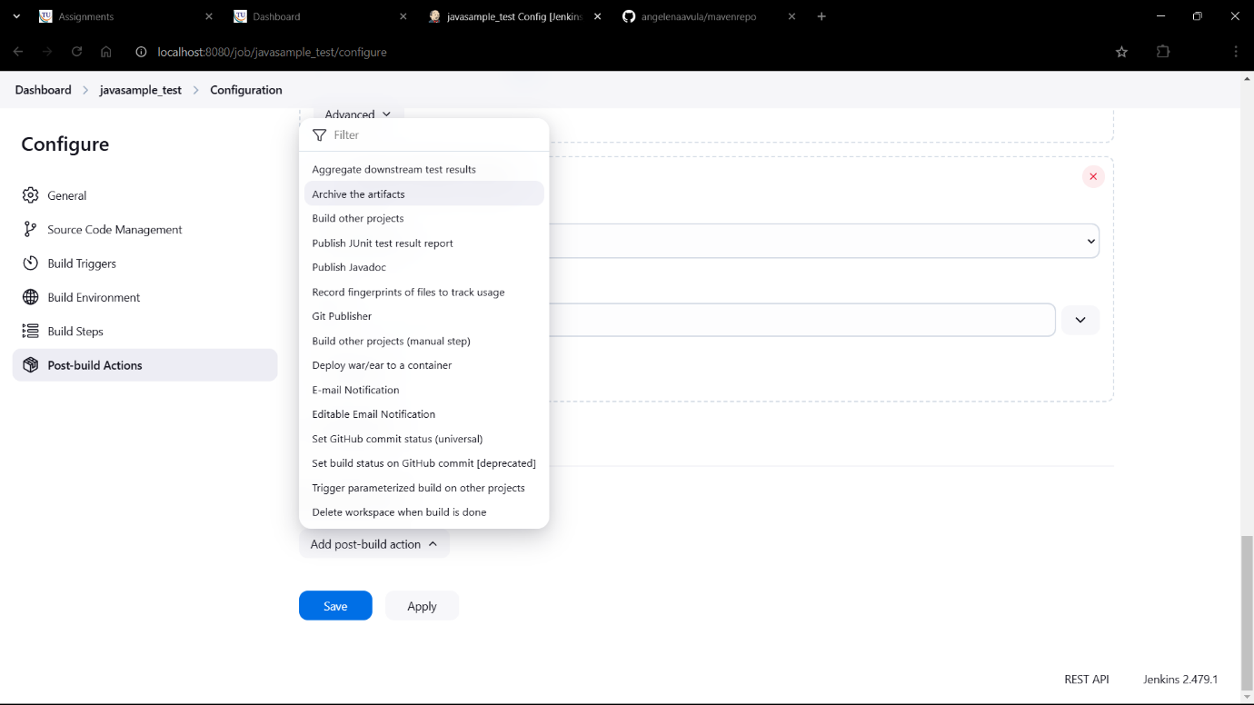

1. Give **/* as files to archive

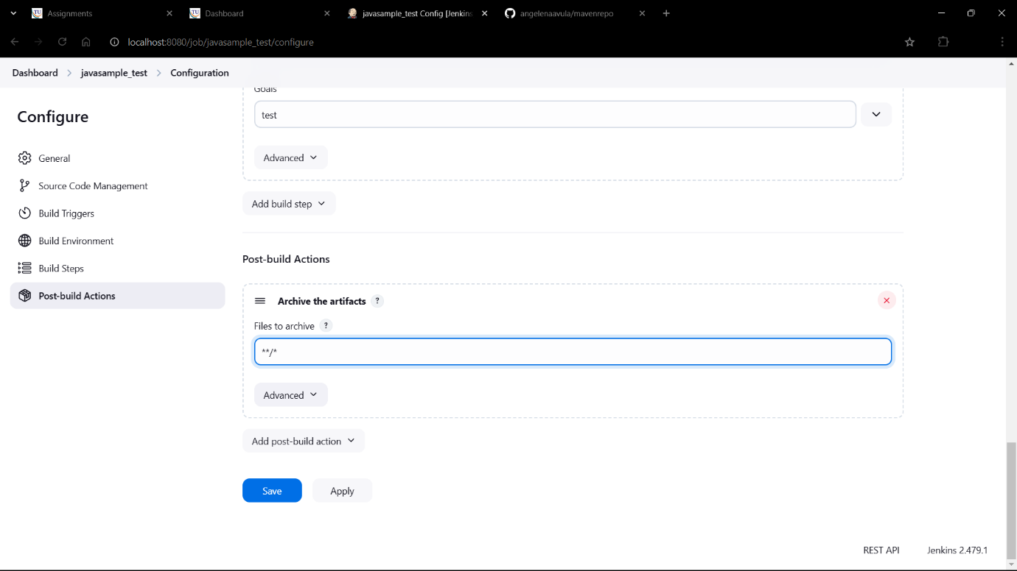

1. Click on Apply->Save

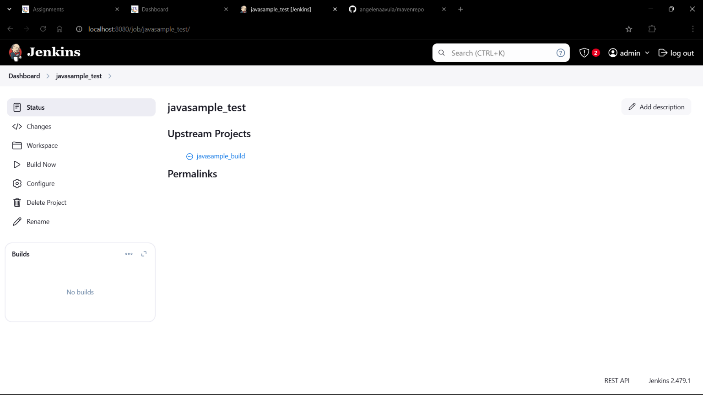

1. Click on new view

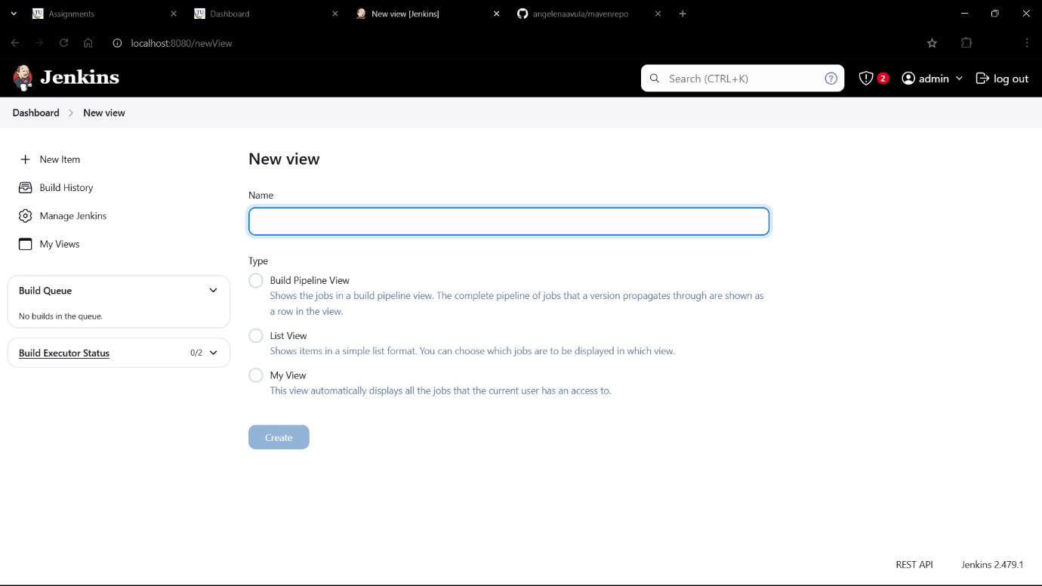

1. Give view name as javasample_pipeline

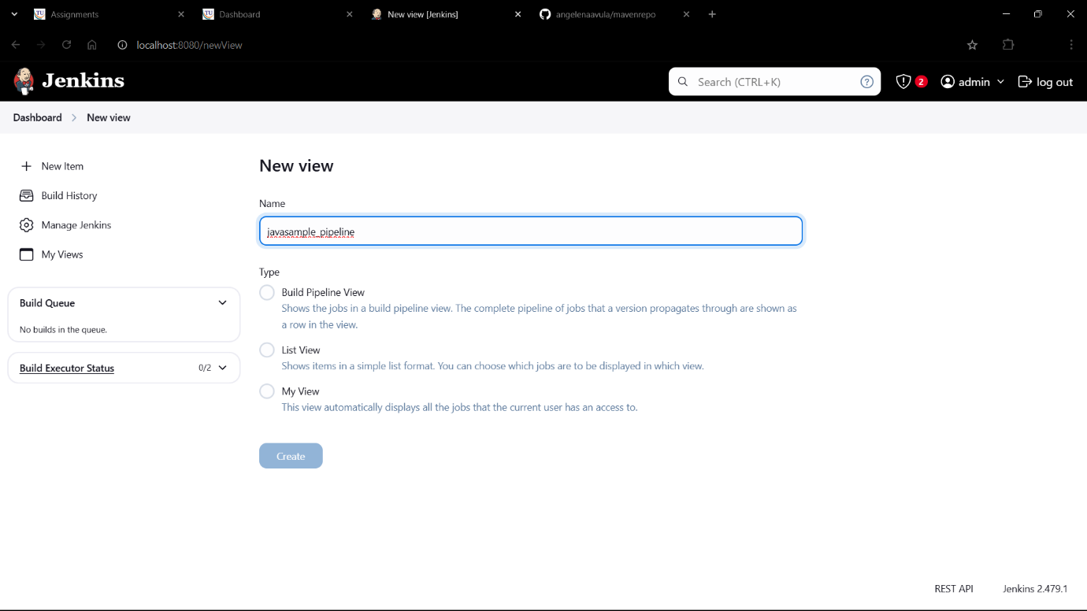

1. Select build pipeline view

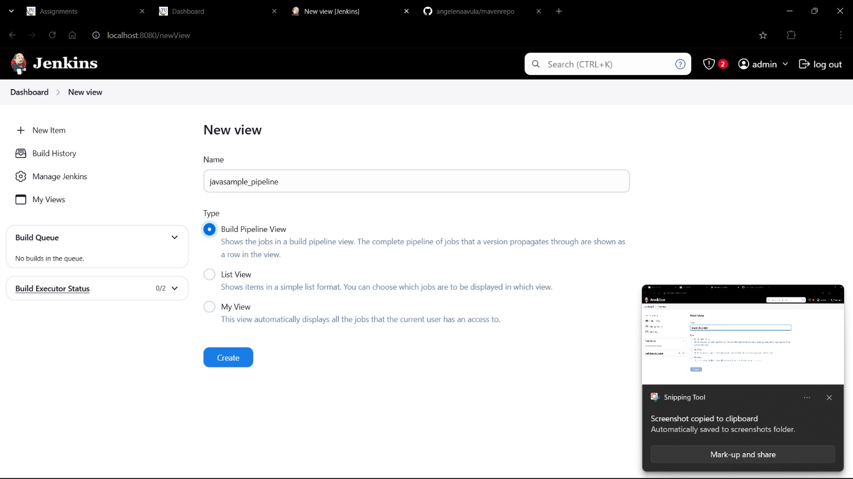

1. Scroll down and select initial job as javasample_build

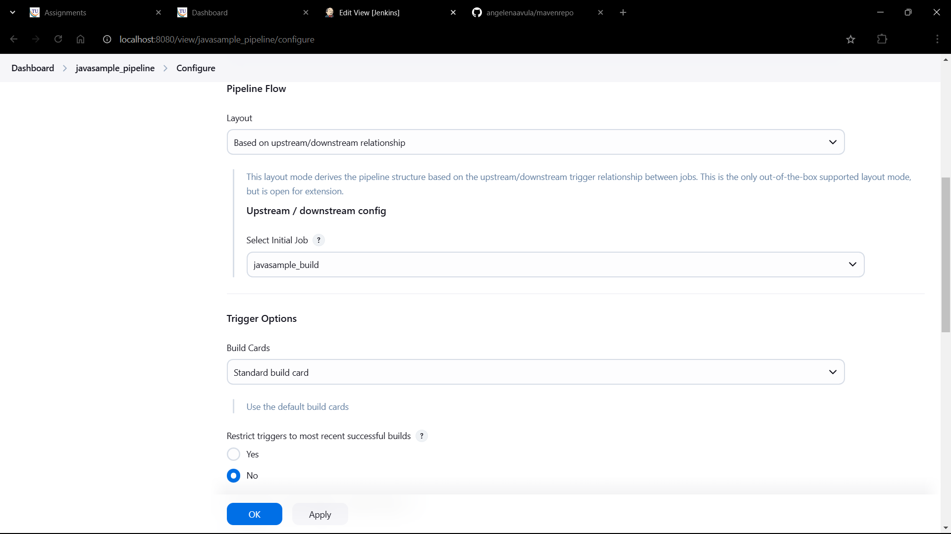

1. Click on Apply->Save

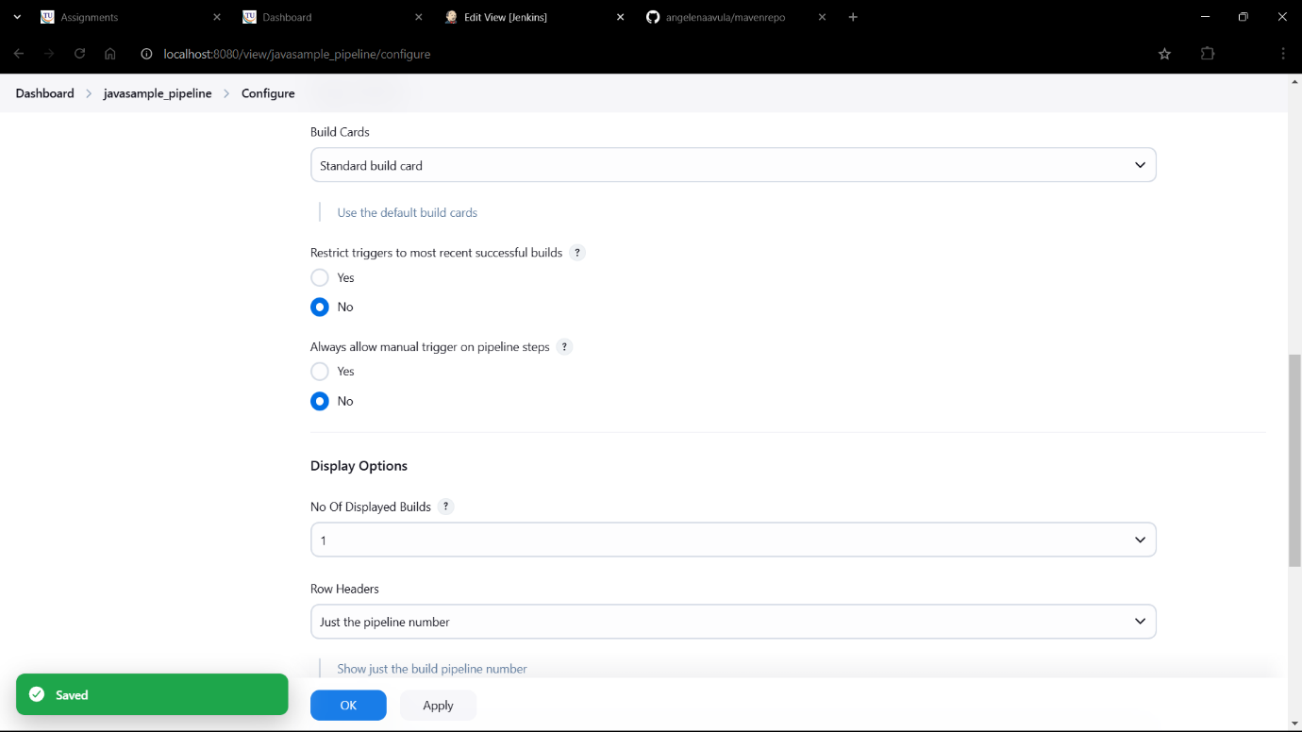

1. Click on Run

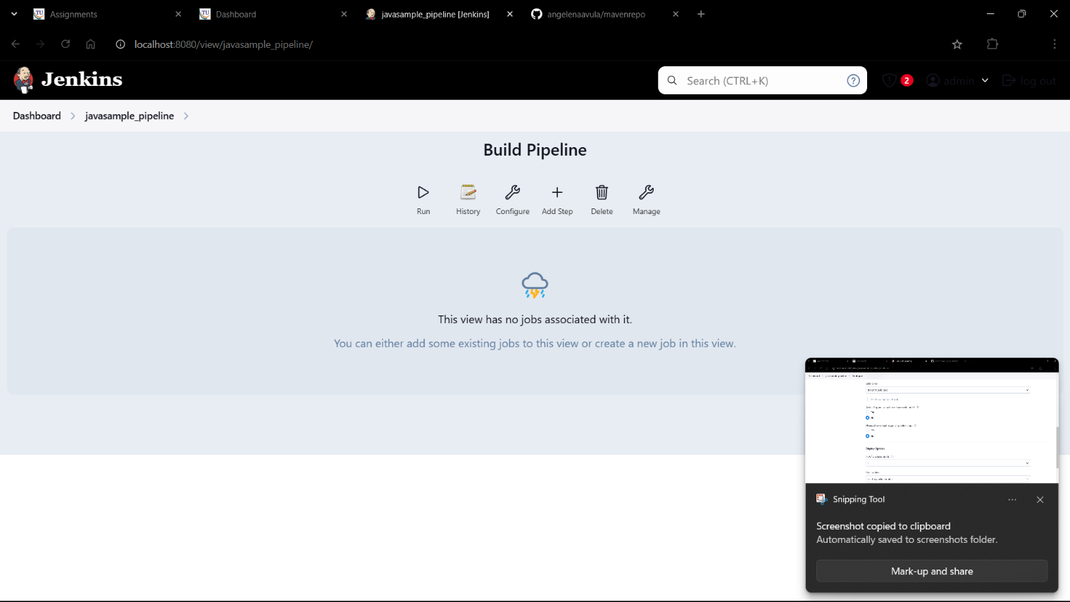

1. Wait till they turn green

Keep refreshing the page

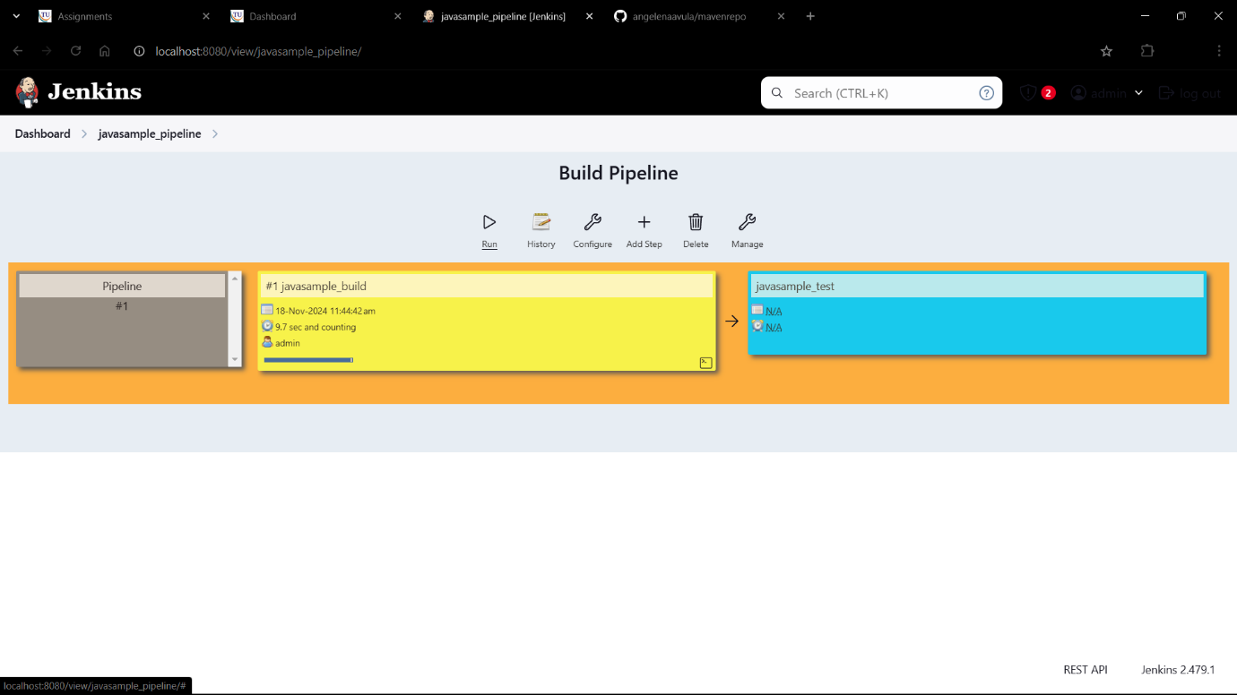

1. They have turned green as shown

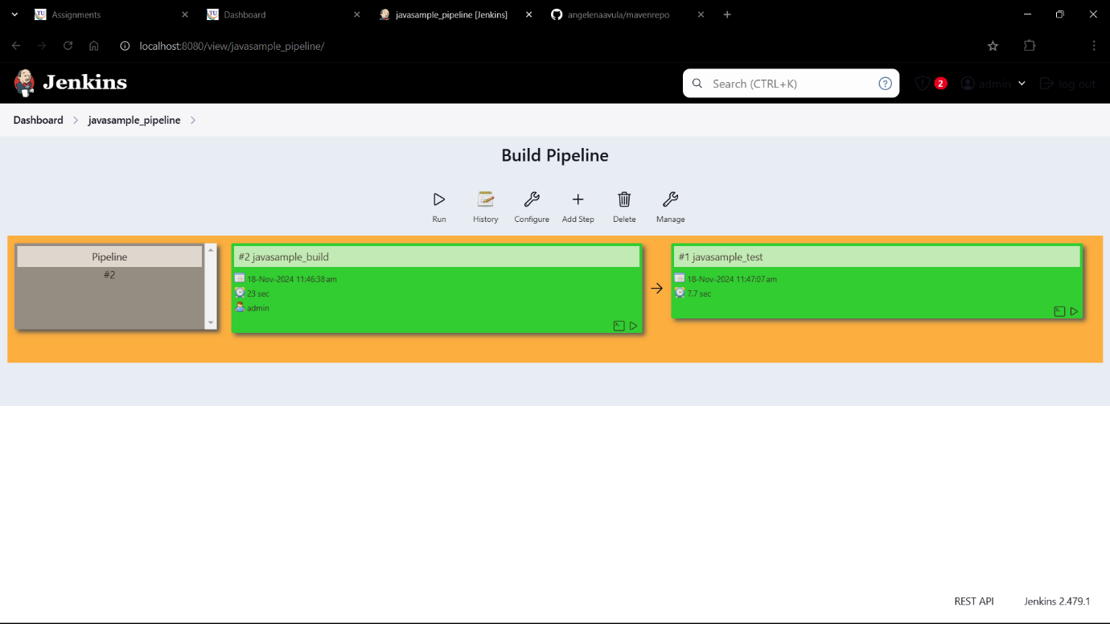

1. The pipeline was successful!!!

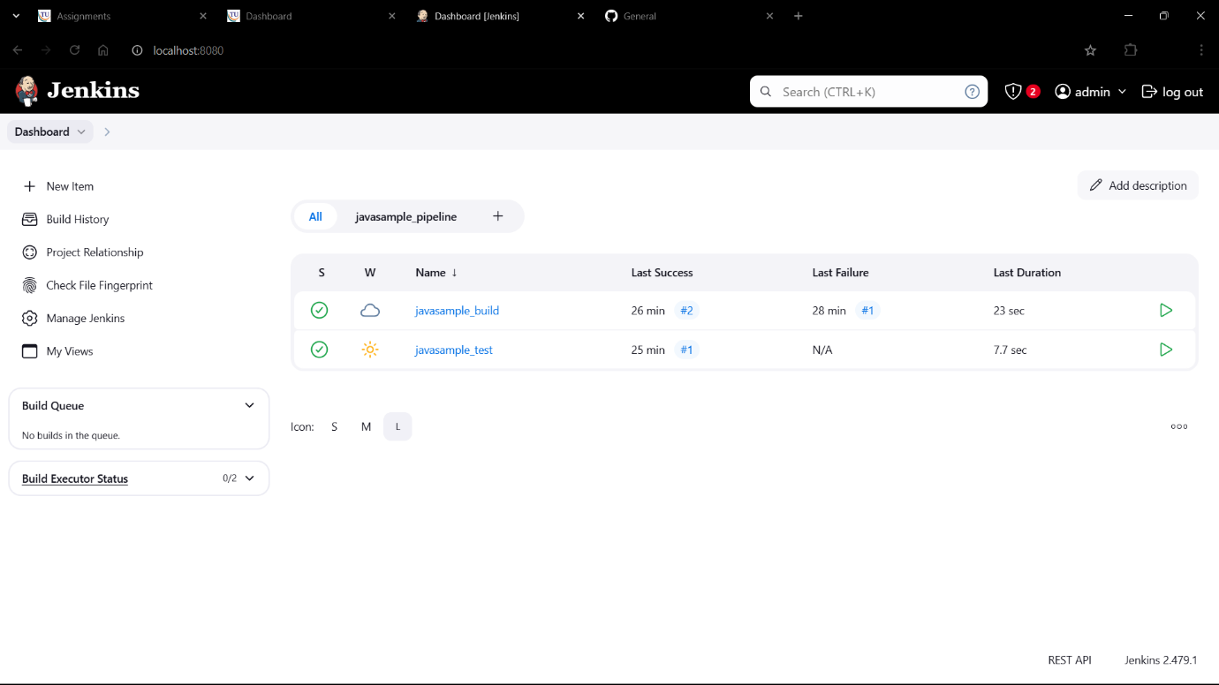

AND THE PROCESS IS DONE!!!!!